Risk Monitoring & Review

🔹 Definition
# Source: AI Source: Provided by: [Data Path: Persons Table -> ID Column: 1, Name_En Column: Motasem Essam] -> From: [Chatgpt (GPT‑5 Mini)] on [8/24/2025]
Risk Monitoring & Review is the ongoing process of tracking identified risks, evaluating the effectiveness of risk responses, and detecting new risks throughout the project or product lifecycle.
It ensures that risks are actively managed and controlled rather than ignored.

🛠️ Objectives of Risk Monitoring & Review
# Source: AI Source: Provided by: [Data Path: Persons Table -> ID Column: 1, Name_En Column: Motasem Essam] -> From: [Chatgpt (GPT‑5 Mini)] on [8/24/2025]
- Track identified risks and monitor their status.
- Evaluate the effectiveness of implemented risk responses.
- Identify new risks that may emerge during the project.
- Ensure timely updates to the risk register and mitigation plans.
- Support decision-making and corrective actions when necessary.

🔹 Key Activities
# Source: AI Source: Provided by: [Data Path: Persons Table -> ID Column: 1, Name_En Column: Motasem Essam] -> From: [Chatgpt (GPT‑5 Mini)] on [8/24/2025]
- Risk Tracking
  - Monitor probability, impact, and occurrence of known risks.
  - Update risk attributes and status in the risk register.
- Reviewing Risk Responses
  - Check if mitigation or contingency plans are effective.
  - Adjust strategies if risks are not controlled.
- Identifying New Risks
  - Conduct periodic risk assessments to discover emerging risks.
- Reporting and Communication
  - Regularly inform stakeholders about risk status and changes.
  - Provide dashboards or risk reports for transparency.
- Lessons Learned
  - Document lessons from risk events for future projects.

📊 Example Scenario
# Source: AI Source: Provided by: [Data Path: Persons Table -> ID Column: 1, Name_En Column: Motasem Essam] -> From: [Chatgpt (GPT‑5 Mini)] on [8/24/2025]
Project: Online Banking Application
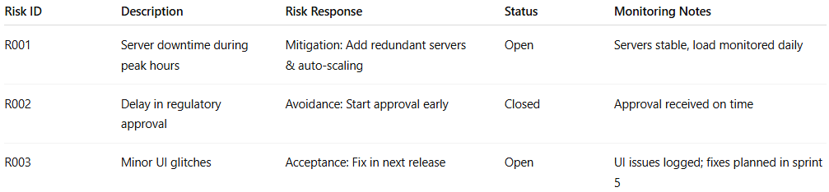
Risk ID | Description | Risk Response | Status | Monitoring Notes
R001 | Server downtime during peak hours | Mitigation: Add redundant servers & auto-scaling | Open | Servers stable, load monitored daily
R002 | Delay in regulatory approval | Avoidance: Start approval early | Closed | Approval received on time
R003 | Minor UI glitches | Acceptance: Fix in next release | Open | UI issues logged; fixes planned in sprint 5

🔹 Importance of Risk Monitoring & Review
# Source: AI Source: Provided by: [Data Path: Persons Table -> ID Column: 1, Name_En Column: Motasem Essam] -> From: [Chatgpt (GPT‑5 Mini)] on [8/24/2025]
- Ensures risks are actively managed throughout the project.
- Helps in early detection of new risks.
- Evaluates the effectiveness of mitigation plans.
- Supports proactive adjustments to prevent negative impacts.
- Enhances stakeholder confidence and project success.

✅ In short:
Risk Monitoring & Review = The continuous process of tracking risks, evaluating risk responses, identifying new risks, and updating plans to ensure effective risk management.

